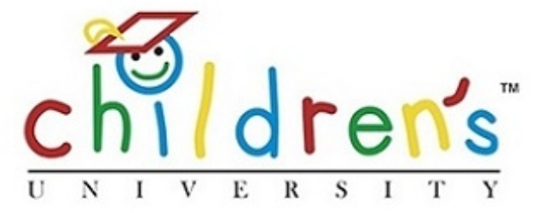
Dear Parents,
Norwood Primary School will be collaborating with Adelaide University and making the Children’s University program available to our Year 3/4 classes in semester 2, 2017. This program will be a pilot program and if successful, it will be introduced more widely and offered to other year levels in 2018. Numbers of students involved will be capped at 50 for 2017.
This afternoon a representative from Adelaide University spoke briefly to the Year 3/4 classes about the Children’s University program. Students were given the opportunity to ask questions.
All students were given an introductory letter from the Children’s University to bring home to parents.
What now?
- If interested, each child will be required to pay an enrolment fee of $25 + GST ($27.50). This can be paid to our Front Office from Monday 5th June. It will be forwarded to the university.

- The university will then issue each student with a Passport to Learning in which the hours of each validated activity are to be recorded.

- Students and families will be expected to take responsibility for attending Learning Activities provided by local providers (including sports clubs, museums, galleries, school clubs). These activities place a strong emphasis on experience as a significant learning tool, acknowledging the value of the range of different learning experiences and environments in which children engage.

- On the Children’s University website there are lists of the learning activity destinations that children can visit outside of school hours. All Learning locations provide activities that children can choose to do, either independently or with their family. Students will receive a stamp in their Passport to Learning and will record the number of hours they were engaged in the activities.

- All learning activities have a link in some way to a university course eg. football club = sports engineering, physiotherapy, management, teaching, sciences etc.

- Once a child has reached the required number of hours, children will graduate from the Children's University. The student’s achievements are recognised through the award of a formal certificates and a graduation at an award ceremony held in high profile locations eg. Bonython Hall. (No extra cost)

A parent Information session for participants will be held in the library on Tuesday June 13th. It will be a time to ask questions and chat to staff about the program. We look forward to meeting with you and your child. Activities offered by Norwood Primary School will be outside of normal lesson times and may include before school, after school, lunchtimes and weekend activities. A list of possible activities will be provided to participants.

Detailed information on the Children’s University can be found on the website at Children's University Adelaide
Regards,

The Year 3/4 Team

